- write a SQL query to find the first name, last name, department number, and department name for each employee.

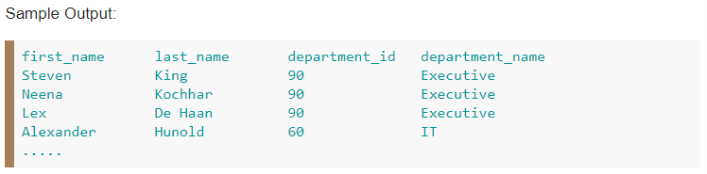
- write a SQL query to find the first name, last name, department, city, and state province for each employee.
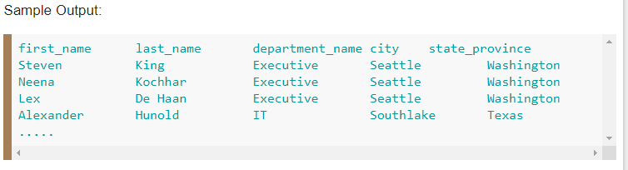
- write a SQL query to find the first name, last name, salary, and job grade for all employees.
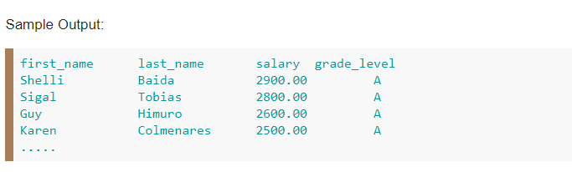
- write a SQL query to find all those employees who work in department ID 80 or 40. Return first name, last name, department number and department name.
